Table of Contents

1. Introduction 1

2. How to Build the Executable 1

3. Mesh Message decoding 2

4. How to Use: 4

**1.** Logging: 6

2. Mesh 6

**3.** FW Update 8

4. Parameters 9

5. AT Commands 11

6. PPU mode 15

# Introduction

The RBU Debug GUI is an application GUI developed in Python to support the development and the debug of the CYGNUS II RBU. It supports a variety of features like:

* Serial Debug console
* Decoding of the Mesh Data into plain textual description
* AT commands
* Parameter management
* Mesh control and topology representation
* Firmware Update
* Logging
* etc.

Beside Python as the coding language, this application uses the Tkinter library, as Interface to the GUI component management, and other free open-source Python packages.

The Debug GUI can be executed from the Python Interpreter (the entry module is cygnus_gui.pyw) or can be converted into an executable as shown later in this document.

# How to Build the Executable

PyInstaller package is used to create the application exe file, it wraps all the required packages in a single bundle that can be transferred between computers and shared with other engineers without the need for any further dependency installation on other host machines.

First, you need to install PyInstaller - <https://www.pyinstaller.org> by running this command on your local machine:

*Python.exe -m pip install PyInstaller*

From the Windows PowerShell or the Command Prompt, run the gen_exec batch file. Please note that you might need to install some few additional missing packages the first time your run this command. The screenshot below shows a successful generation:

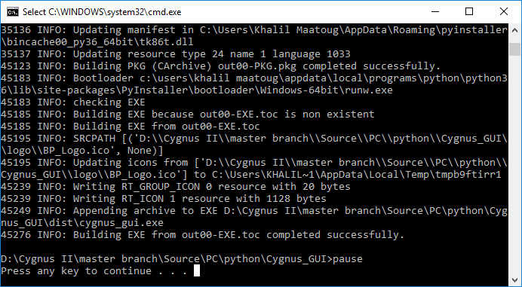

The executable is stored in the “dist” folder under the same location of the script.

# Mesh Message decoding

The $\Source\PC\python\PY_MC_PUP folder contains a Python wrapper of pack and unpack mesh protocol module from the RBU Software (MC_PUP.c).

The Install batch can be executed to build and install the PY_MC_PUP package into the local Python library folder then it can be used as a standard package from any python script running on the local machine.

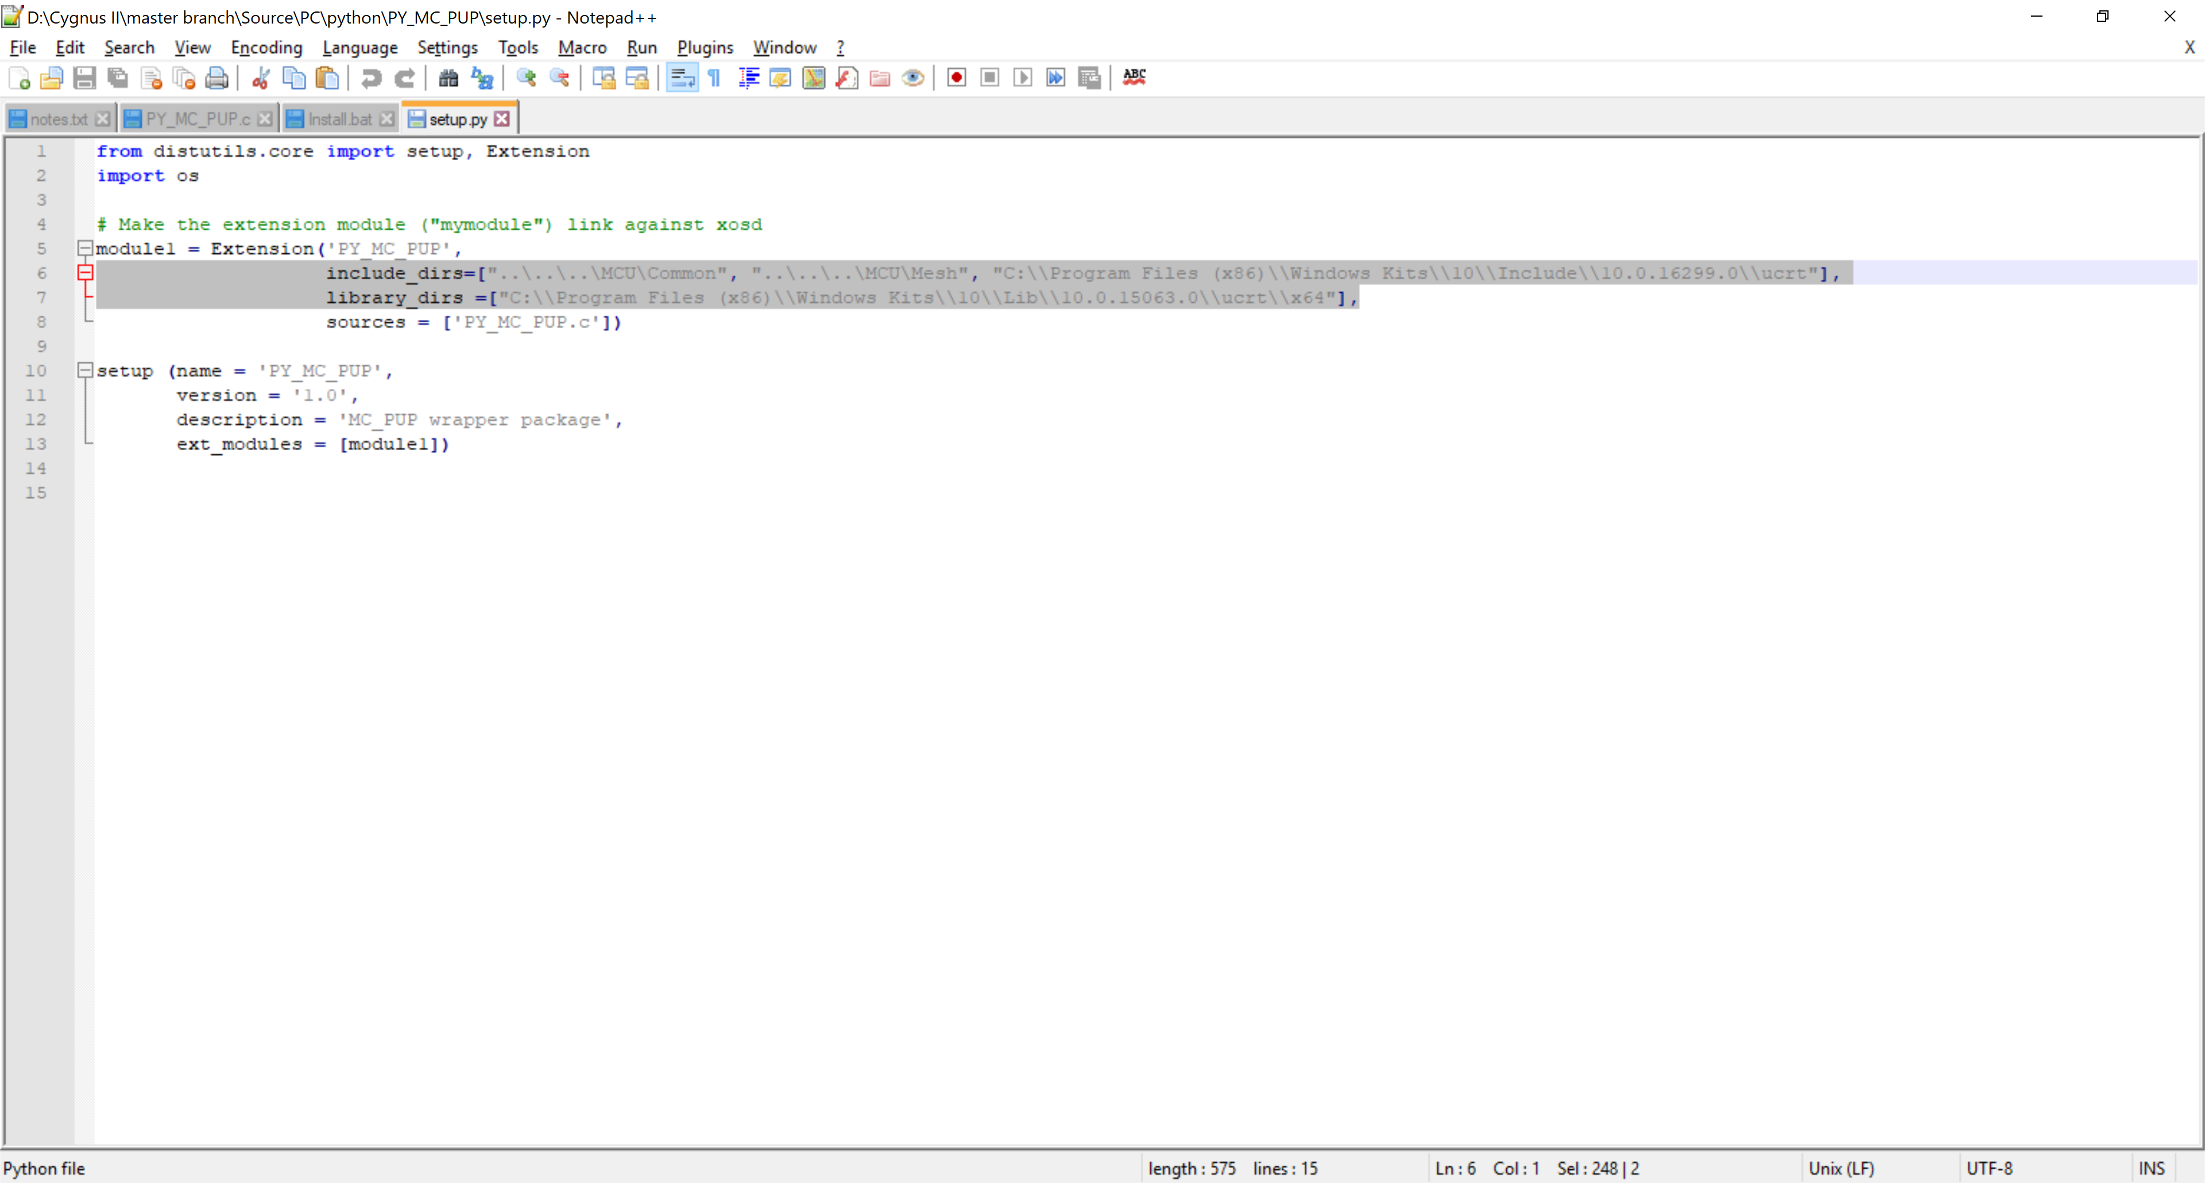

Make sure that the include_dirs and library_dirs include the paths to the Microsoft Visual Studio development kits as it might not be found automatically by Python.

The PY_MC_PUP.c file is the actual wrapper file as it does invoke the functions from the MC_PUP.c to decode the Mesh packets and extract the value of each member and return a Python-Dictionary as a Python-Object to the caller script.

If there is any change in MC_PUP.c, then you need to check if there are any changes that might be needed in the PY_MC_PUP.c file to keep in sync.

# How to Use:

Run the application:

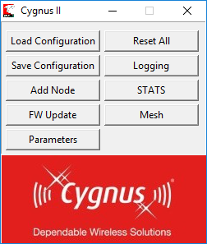

First time, you need to define your system. Click on “Add Node” button:

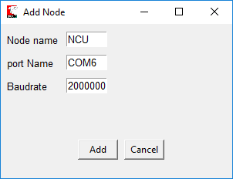

And click Add.

Define all the nodes in your system

*PS: The Node name is arbitrary but make sure that you define your NCU device with the “NCU” name as it used to control the mesh state.*

By default, a node window is opened in its full size:

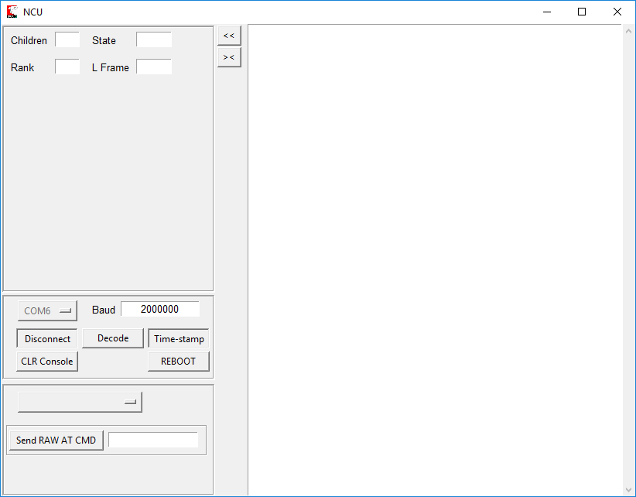

The node window can be reduced either manually or by clicking on the ‘><’ button:

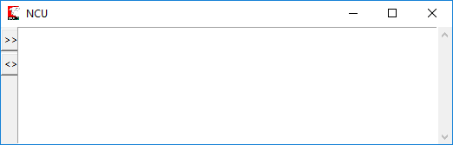

After positioning and resizing the windows of all your nodes, enable the logging if needed, then you can click on the “Save this Configuration” button to keep a record of your preferences in a JSON file for later use.

To reload your preferences at the start-up, click on the “Load Configuration” button from the main window and then select your pre-saved JSON file.

## Logging:

The Logging button allows you to record all the serial activity along with the decoded content by this application for later analysis by the user.

The log files are stored under the folder “logs” in the same location as the application exe file. A folder named with the date and time is created each time a logging operation is started. For each node a log file is created with “NodeName Date Time”.log as file name.

The files are flushed into the disc every minute to be able to consult them in the run time with no need to close the application for that.

## Mesh

To control the mesh state, click on the Mesh button from the main window:

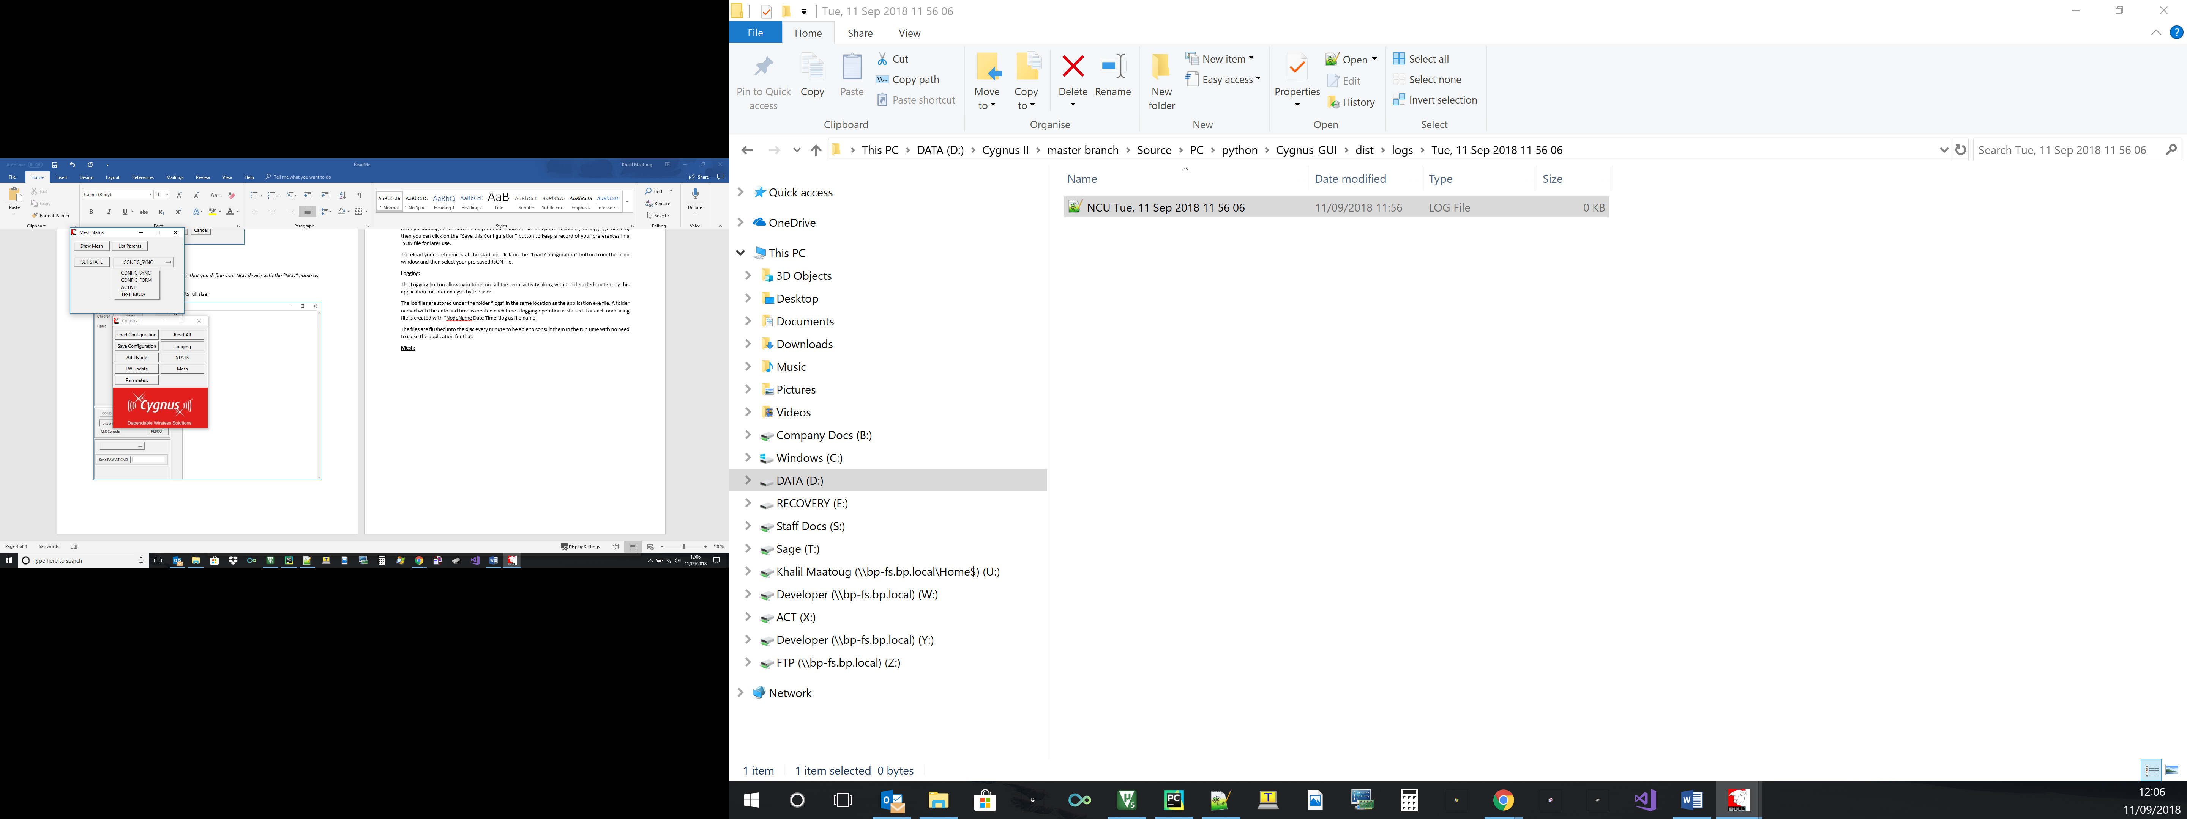

Select the desired state from the menu list as shown above and click on “SET STATE”. This operation would be requested from the node named NCU in your system so make sure you defined correctly the NCU node.

Once the System is in the active state, you can get the Mesh formation topology by click on the “Draw Mesh” Button which will generate a Graphical view and a list representation of the network as shown below

The application issues the ATNODES command to all the defined node of the system which respond with their rank, parents and children.

Having the information for each node of the system, we can build the representations below.

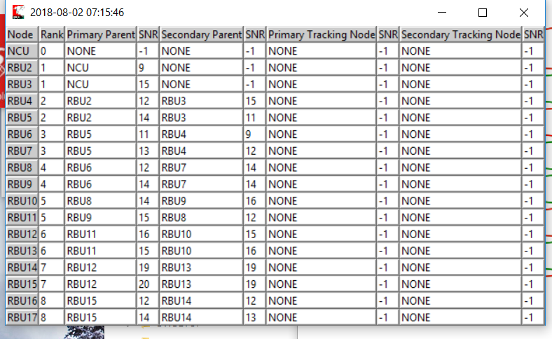

A user-friendly view:

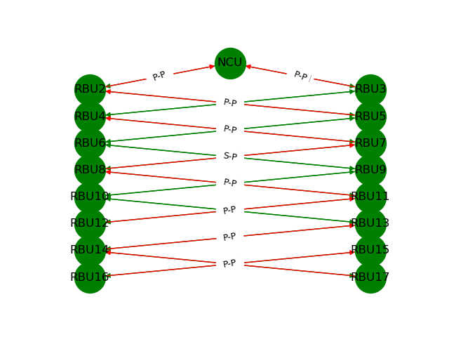

## FW Update

The Firmware Update Operation is an automated sequence that allows the update of all the nodes of the System in few clicks.

First click on the “FW Update” from the main window:

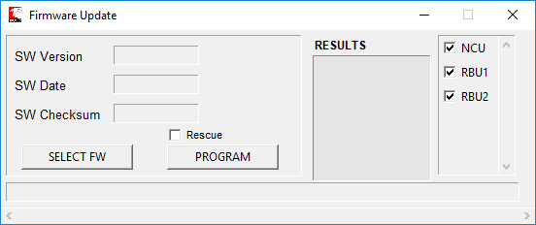

Click on “SELECT FW” button to load the binary file you wish to program.

Untick any node from the list on the right side if you like to exclude it from the programming operation.

Click on the “PROGRAM” button and wait for the end of the operation:

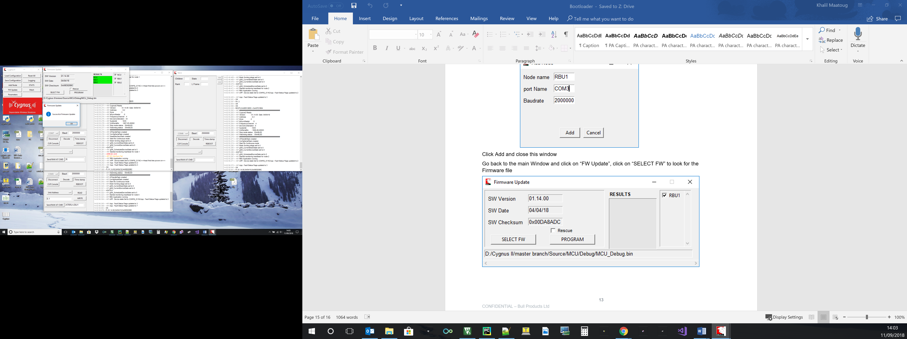

The “Rescue” box can be ticked in the case of an unstable SW to halt the start-up operation of the board and request from it to go into the bootloader mode and then reprogram it.

In such a case just tick the “Rescue button” before clicking on the Program Button.

## Parameters

This feature allows the user to read/write or save/reload the configuration parameters of all the nodes in the system.

Click on Parameters:

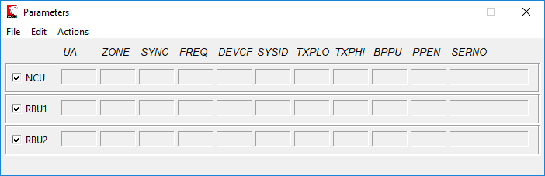

Go on Actions->Read to read all the parameters:

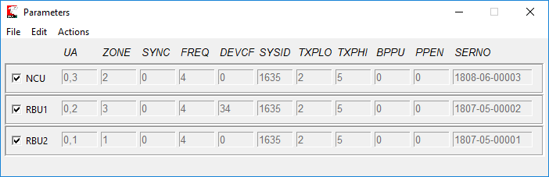

To save a record of this current configuration for later use, go to File->Save and give a name to your JSON parameter file.

To load this configuration later do File->Load and select the pre-saved JSON file.

To modify a parameter go to Edit->Unlock and modify manually the parameter you wish for the nodes.

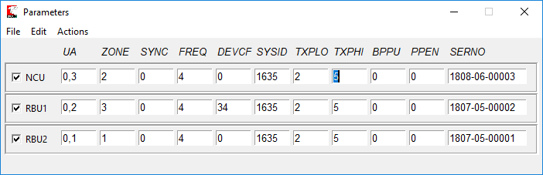

If you like to set a common value to all the nodes then go to Edit->Common, select the parameter you like, set the desired value and click on the “SET” button

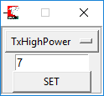

To write all the new parameters into the devices, go to Actions-Write

When the operation is finished you will be prompted with a confirmation window to verify that the writing was successful.

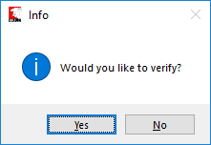

Click on the Yes Button if you wish to verify, this will read back all the parameter values and check them against the pre-written values.

If all is successful, then you will get a final confirmation:

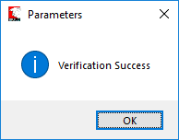

## AT Commands

The AT command operation is available on the window of each node:

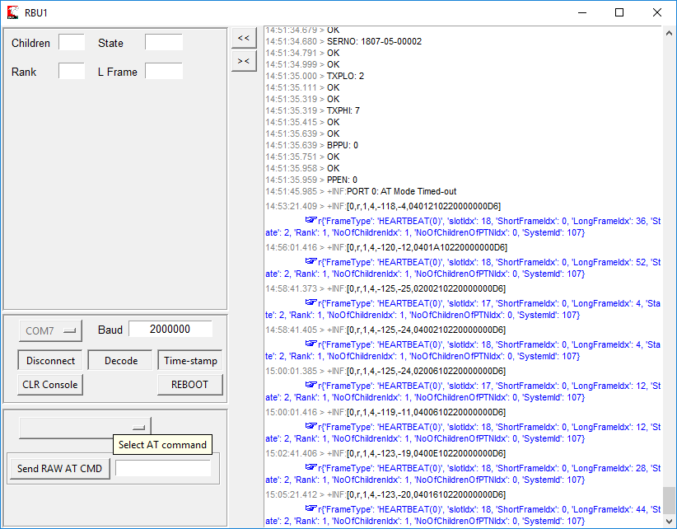

You need to select the command you like to use from the menu list:

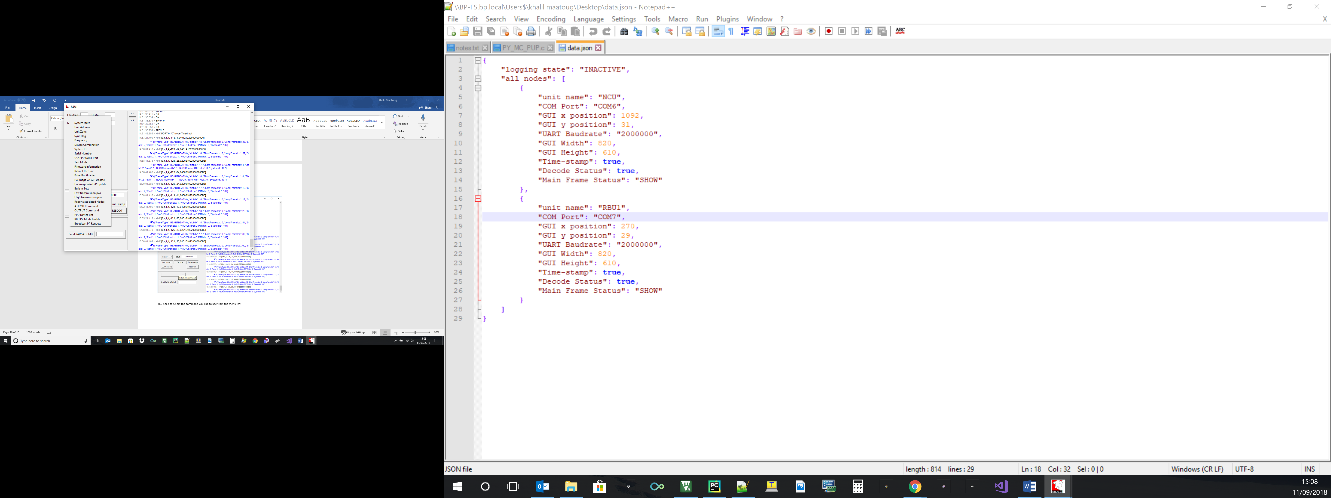

Depending on the operation you select, different items would be shown:

Read/Write command:

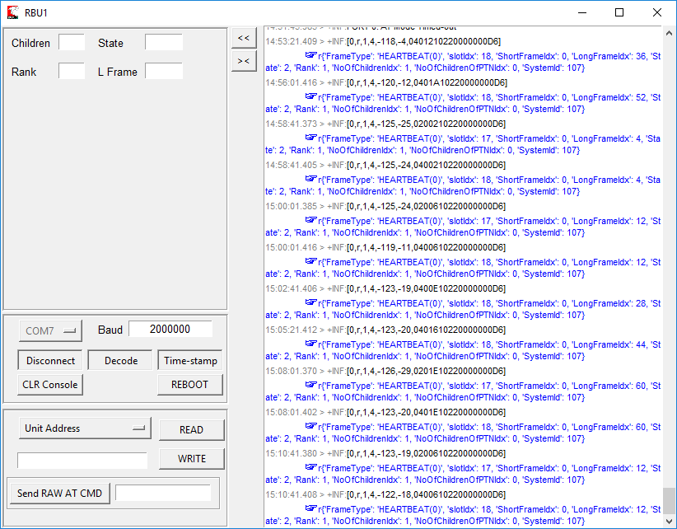

Special command:

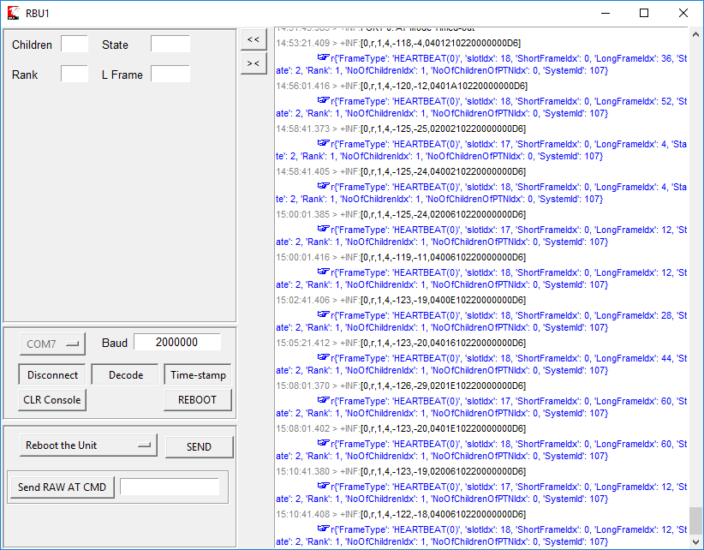

Read-Only command:

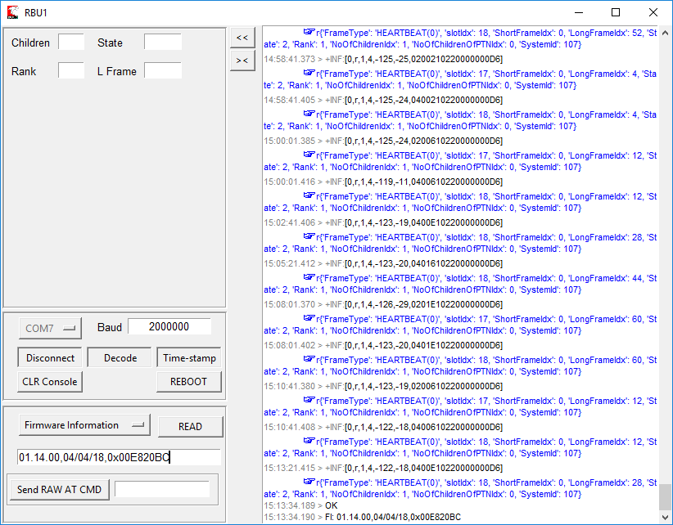

ATCMD command:

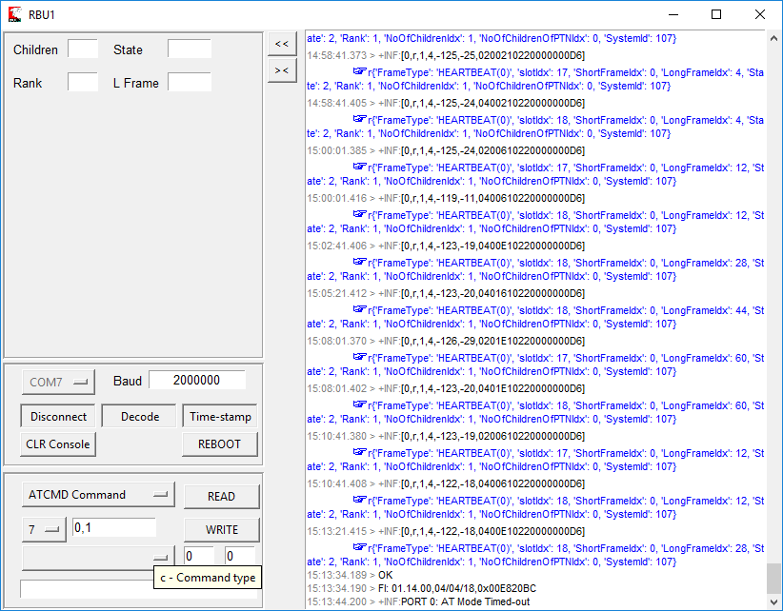

The Transaction ID is incremented each time you send a new command

The Command type widget is a menu list to choose the type of command:

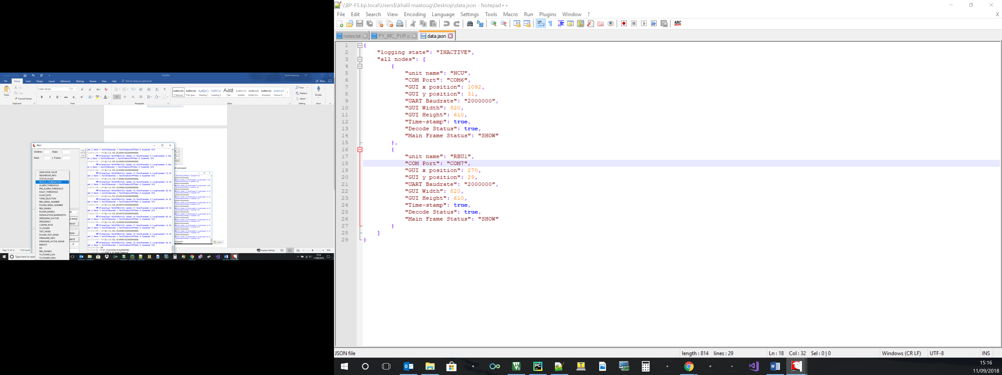

ATOUTPT command:

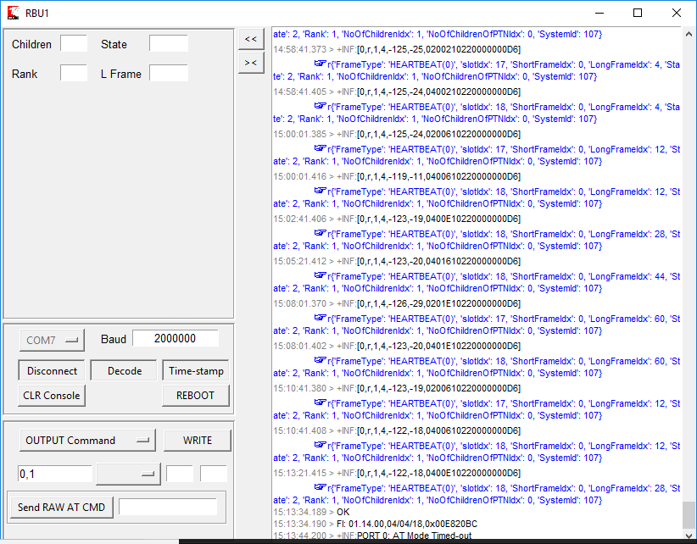

List of outputs:

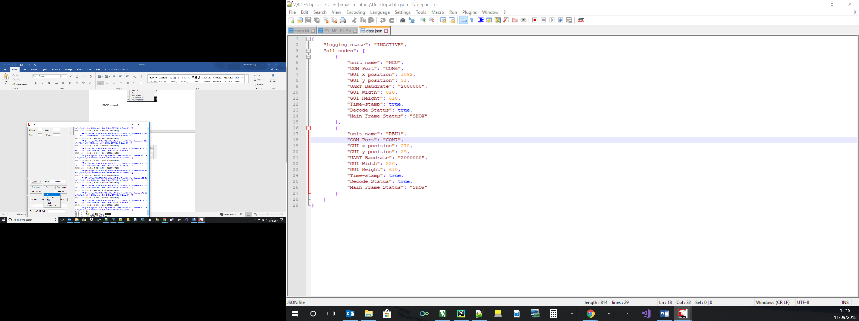

The RAW AT CMD box allows you to experiment or send a new AT commands without the need of modifying the application GUI code or rebuild the executable:

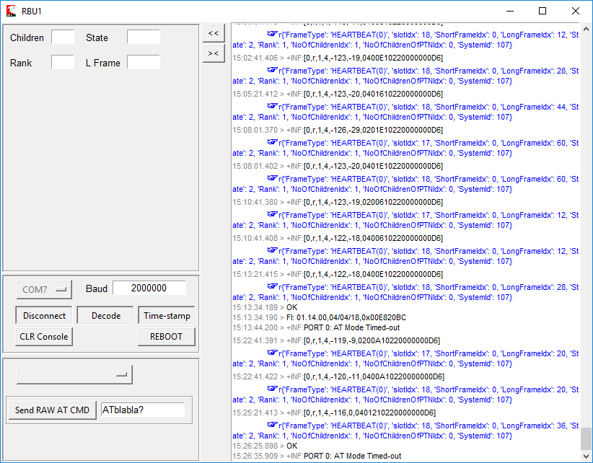

## PPU mode

When a node is name “PPU” in the configuration then its windows is slightly different to support some additional functionalities of the PPU-RBU:

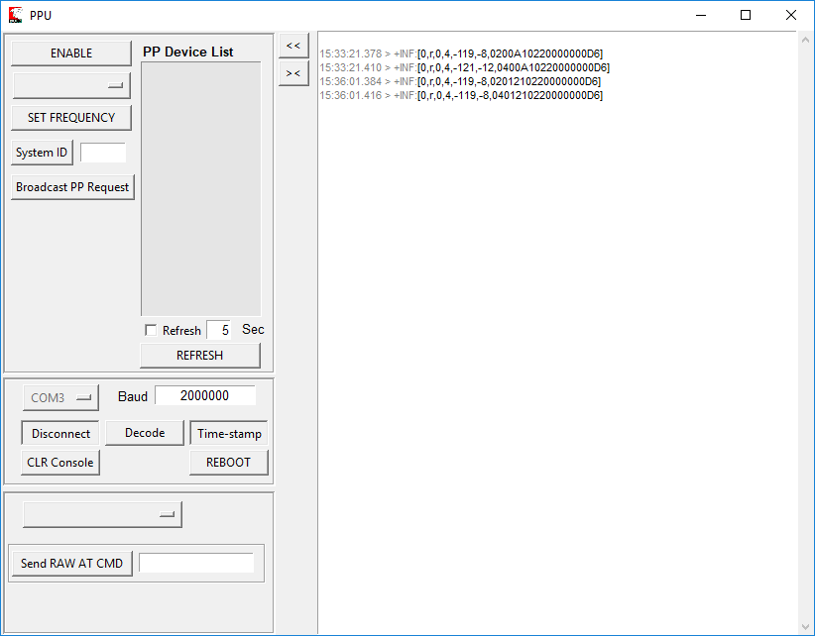

Click on the “ENABLE” button to activate the listening mode.

You can either activate the periodic refresh mode by ticking the Refresh box and setting the desired refresh period or manually click on REFRESH. Then any RBU in surrounding area detected in the Peer to Peer mode would be added to the “PP Device List” as they are reported through the ATPPLST command. The devices are represented with their serial number.

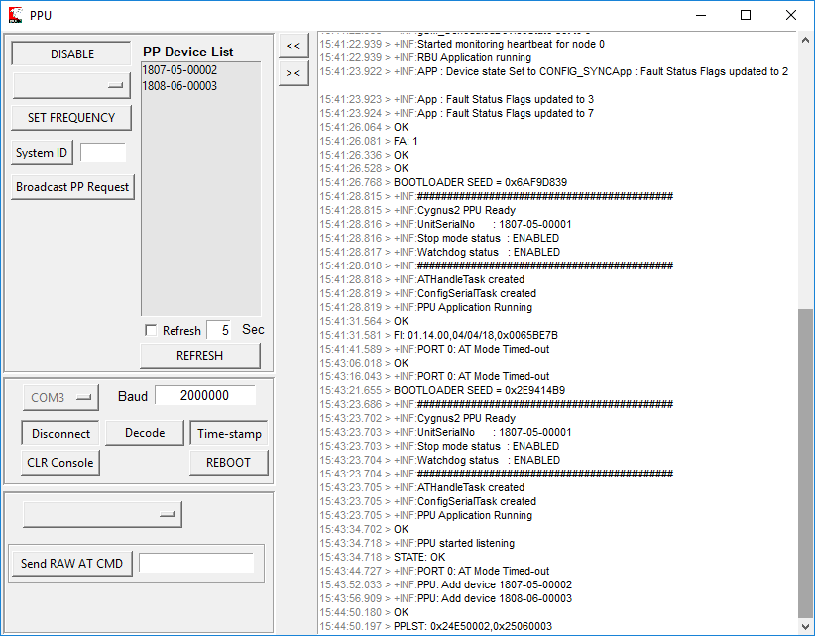

Double click on the Serial Number of the Device you want to communicate with and this will automatically fill-in the serial number in the destination box of the AT command.

Select the command you want to transmit, fill-in the command parameters or value field for a Write operation.

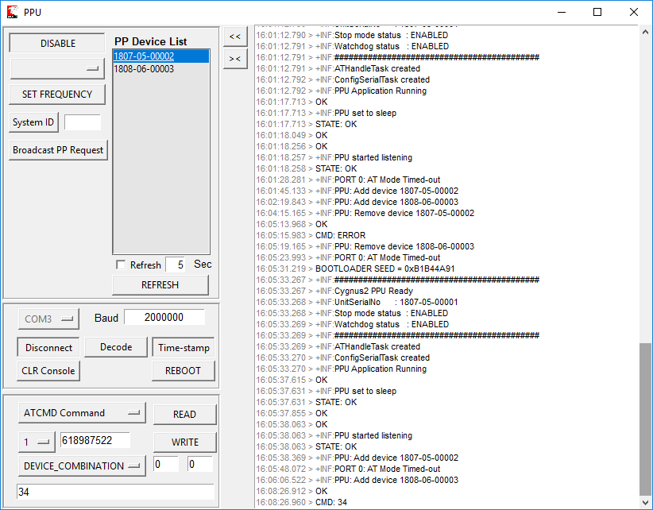

**Broadcast Message:**

The broadcast message was introduced to bring any board to the PP mode that has already moved to the Mesh mode but there is no actual Mesh or control panel to send a Reboot command to it.

For the remote unit to hear this message it needs to be sent on the same default LoRa channel and with the same System ID hence the fields on the PPU window:

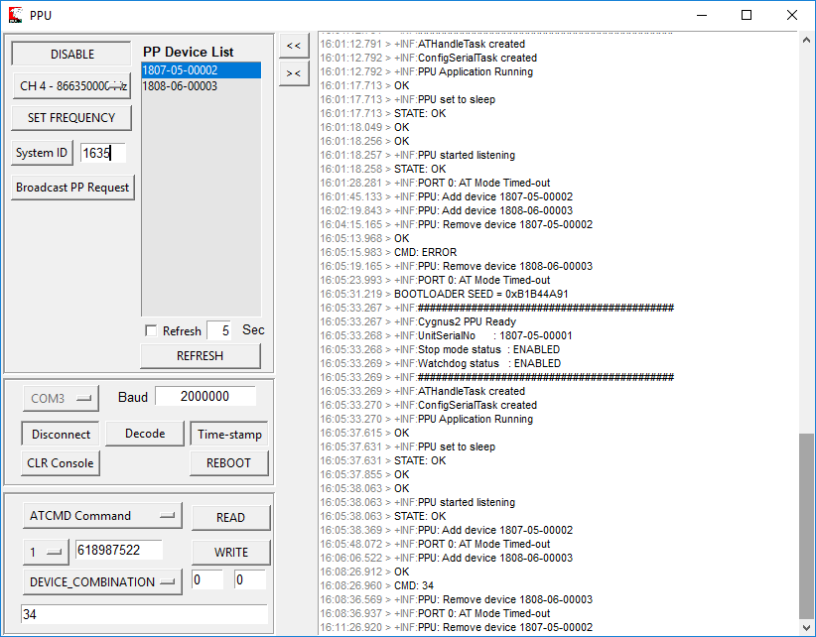

Set the appropriate Frequency Channel and click on the “SET FREQUENCY” button

Type-in the System ID of the remote unit and click on the “System ID” button

Click on the “Broadcast PP Request Button”, then this will send the ATPPBST command to the PPU-RBU to broadcast a message and then any RBU in the nearby area waiting to sync to a mesh will hear this message and reboot if the System ID is matching its own.